ASSIGNMENT SUBMISSION COVER SHEET

cse25-255
Student Id:

Shepherd Tathego
Student names:
cse25-255@thuto.bac.ac.bw
Student email:

Cohort: 2026

SCIS WMD_2026 A01
Assignment title:

23/05/2026
Date of submission:
Computer Systems Engineering
Programme of Study:

YEAR 1
Year of Study:

Intellectual property statement
By checking the box below, I certify that this assignment is my own work and is free from plagiarism. I understand that the assignment may be checked for plagiarism by electronic or other means and may be transferred and stored in a database for the purposes of data-matching to help detect plagiarism. The assignment has not previously been submitted for assessment in any other unit or to any other institution. I
have read and understood the Botswana Accountancy College plagiarism guidelines policy.
☐ Agree Signature STATHEGO
Date 23/05/2026

PHARMALINK WEBSITE SPECIFICATION REPORT
Introduction
Technology has changed the way people access many services nowadays. Many people now prefer using online platforms because they make things easier, faster, and more convenient. Because of this, PharmaLink was designed as a healthcare and e-commerce website where users can access pharmacy services and healthcare products online.
The website aims to improve customer convenience by allowing users to browse medicines, access healthcare information, book consultations, and purchase products through an online platform. In addition, the website seeks to improve communication between the pharmacy and its customers by providing contact and support services.
According to the World Health Organization (2021), digital health technologies help improve access to healthcare services and communication between patients and healthcare providers. Therefore, the PharmaLink platform is designed to support accessibility, efficiency, and customer satisfaction.

Objectives and Goals
The main objective of the PharmaLink website is to provide a user-friendly online platform where individuals can conveniently access a wide range of pharmacy services and healthcare products from the comfort of their homes.
The website helps connect patients and the pharmacy by giving users easy access to healthcare products, professional guidance, and reliable medical information. One of the key goals of the platform is to enable users to browse various categories of medicines and healthcare products, compare available options, and make informed purchasing decisions without physically visiting a pharmacy.
Another important goal is to simplify the purchasing process through secure online transactions and convenient ordering systems. The website also aims to improve communication between customers and pharmacy staff by offering consultation services, support channels, and inquiry options.
PharmaLink also helps users save time, especially people with busy schedules or limited mobility. The platform also promotes health awareness by providing accurate and updated information about medicines, dosage instructions, uses, and possible side effects.
Research by Nielsen Norman Group (2020) shows that user-friendly websites make it easier for users to find and understand information.

Target Audience
The PharmaLink website is intended for a wide range of users who require healthcare products and pharmacy-related services.
The site targets individuals:
- Aged between 18 and 60 years
- Male and female users
- Residents of Gaborone and surrounding areas
- Patients, caregivers, and working adults
Technical Aptitude
The website targets users with:
- Basic internet skills
- Ability to use smartphones and computers
- Access to internet services
- Basic knowledge of online shopping systems
The website interface is designed to be simple and easy to navigate so that users with limited technical experience can still use the platform effectively.

Type of Website
The PharmaLink website is a healthcare and e-commerce website. It combines healthcare information services with online purchasing functionality.
The platform allows users to:
- Browse medicine listings and healthcare products
- Access online consultations
- View health-related information
- Purchase products online
- Make bookings for healthcare services
- Contact pharmacy personnel for support
Combining healthcare services and online shopping helps users meet their medical needs in one place.
According to Statista (2024), the global growth of e-commerce platforms has significantly influenced healthcare businesses to adopt online systems for improved service delivery.

Information Design and Taxonomy
Information Architecture
The PharmaLink website is organized in a simple and clear way so that users can easily find information and move between pages. The design focuses on making the website simple, easy to use, and accessible.
The website follows a hierarchical structure where information is organized from general to specific levels. The Home Page serves as the entry point and provides highlights of products, services, and announcements.
Garrett (2011) explains that good information architecture helps users find information easily and improves user experience.
Main Website Sections
Home Page
The Home Page provides an overview of the website, featured products, promotional information, and quick navigation links.
About Us
This section contains background information about the pharmacy, including its mission, vision, and organizational values.
Products
The Products page displays medicines and healthcare products arranged into categories for easier browsing.
Product Details
This section provides detailed information about specific products, including descriptions, usage information, and pricing.
Services
The Services page outlines healthcare services offered by the pharmacy, including consultations, prescription assistance, skincare services, and healthcare advice.
Services Details
This section provides more detailed information about each healthcare service available on the platform.
Booking
The Booking page allows users to schedule consultations or healthcare-related appointments.
Cart
The Cart page allows users to manage selected products before proceeding to checkout.
Checkout
The Checkout section enables users to enter personal details, confirm orders, select collection or delivery methods, and complete purchases.
This structure improves usability and helps users move efficiently through the website.
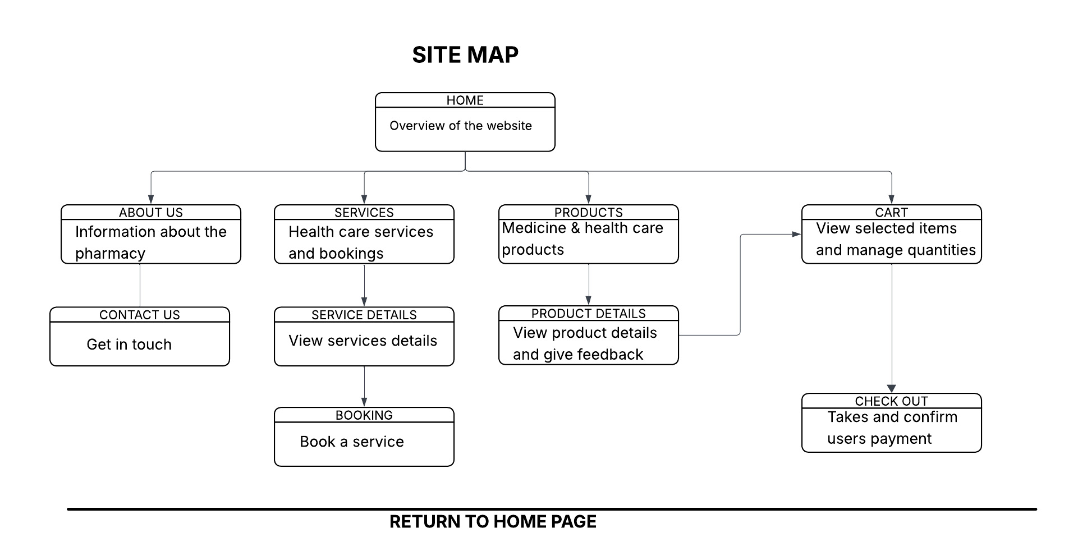

Technical Brief
- Technologies Used
HTML
HTML is used to structure the content of web pages.
CSS
CSS is used to style the website and improve the visual appearance and layout.
Bootstrap
Bootstrap is used to make the website responsive so it can work properly on different screen sizes and devices.
JavaScript
JavaScript is used to make the website more interactive and active for users.
According to MDN Web Docs (2024), JavaScript helps websites become more interactive and engaging.

Development Tools
Visual Studio Code
Visual Studio Code is used for writing and editing website code.
GitHub
GitHub is used for version control and website hosting.

Design and Planning Tools
Lucidchart
Lucidchart is used to create navigation flowcharts and site maps.
Microsoft Word
Microsoft Word is used for report writing and documentation.

Graphics and Resources
The website uses:
- Free online healthcare and medicine images
- Simple graphic design tools for visual elements
These technologies and tools are suitable for creating a simple, responsive, and user-friendly healthcare website.

Page Template Design
Home Page
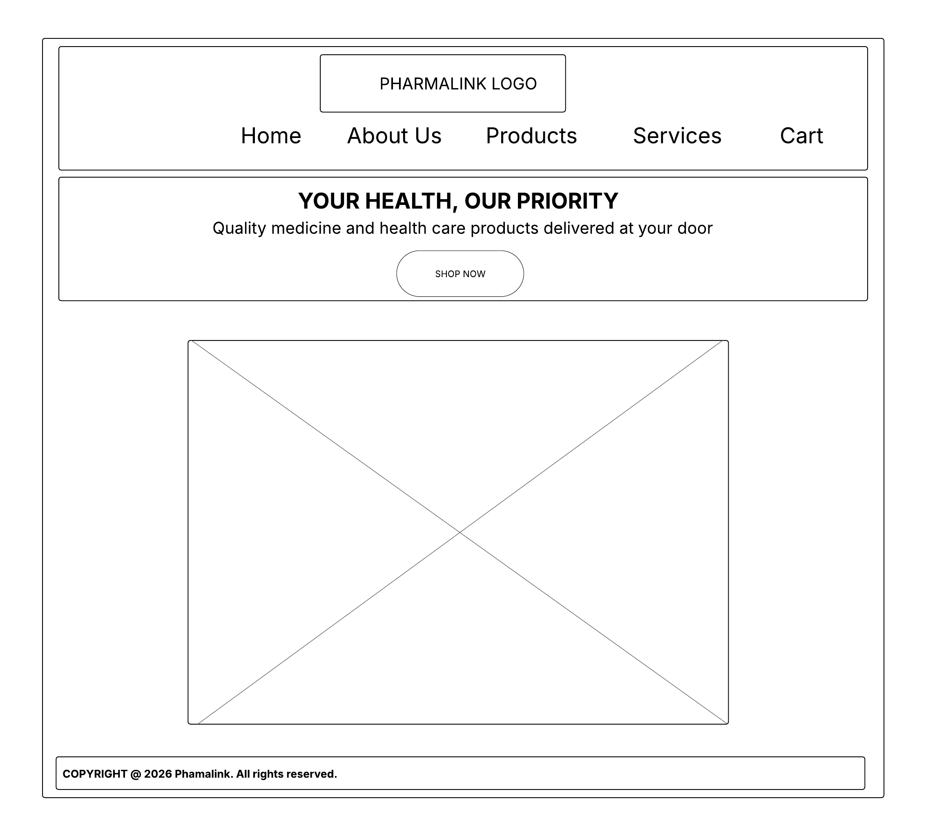
The Home Page is designed to introduce users to the PharmaLink platform. It includes featured products, promotional banners, navigation menus, and quick access links.

About Us Page
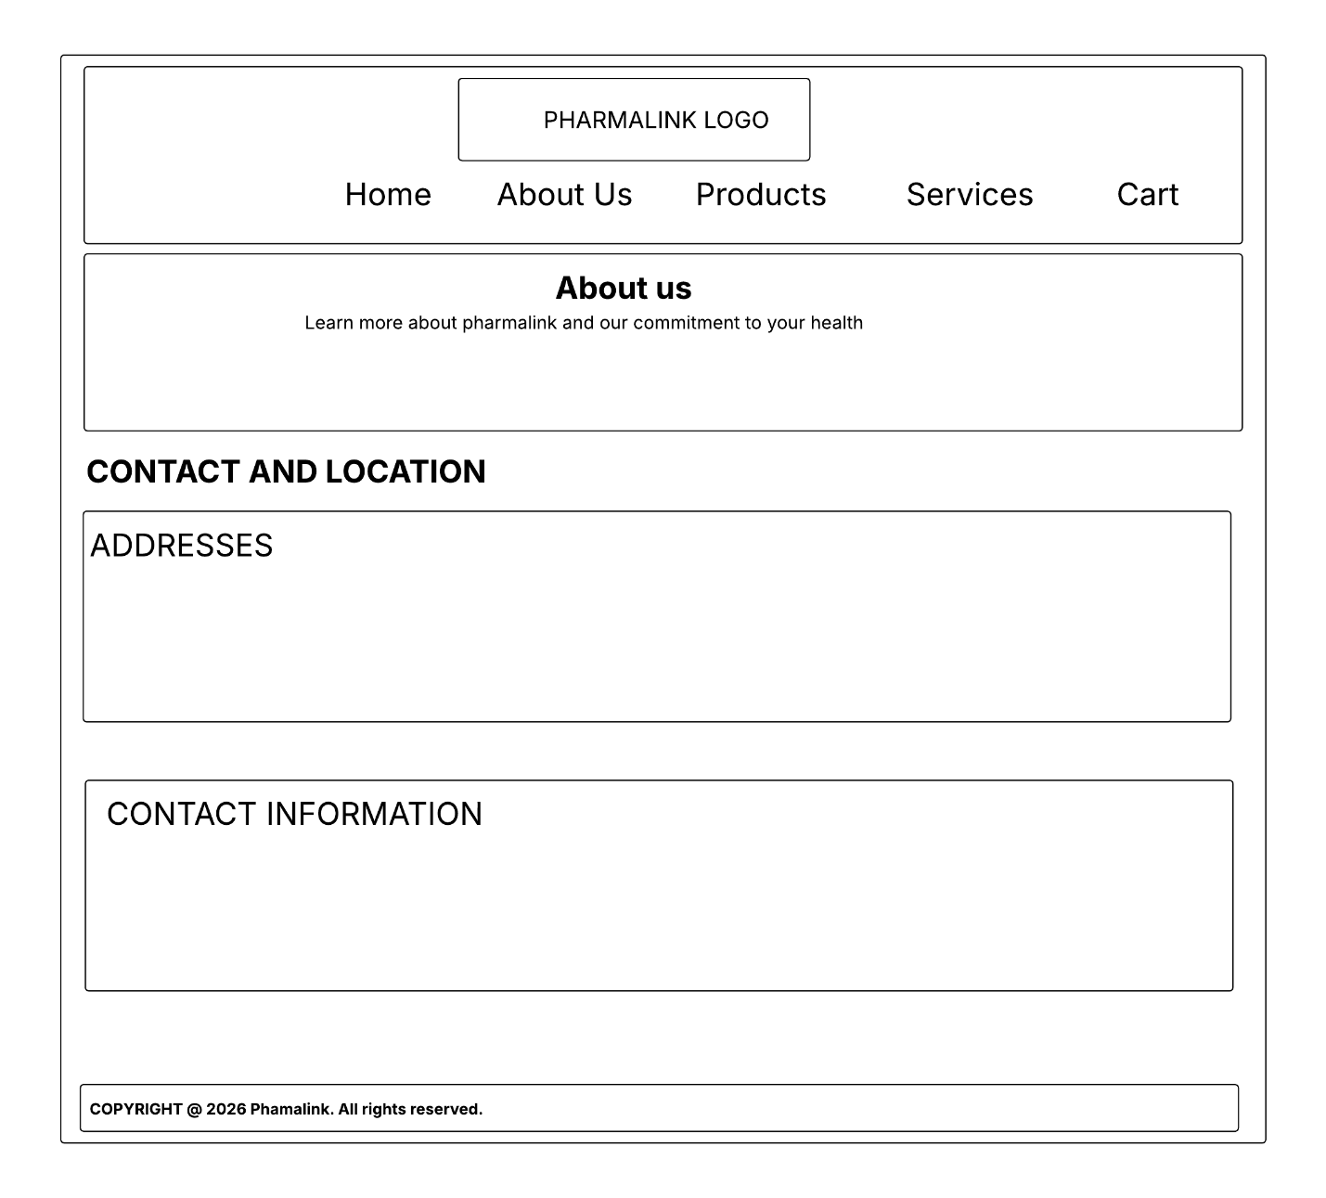
This page provides organizational information, mission statements, and background details about the pharmacy.

Products Page
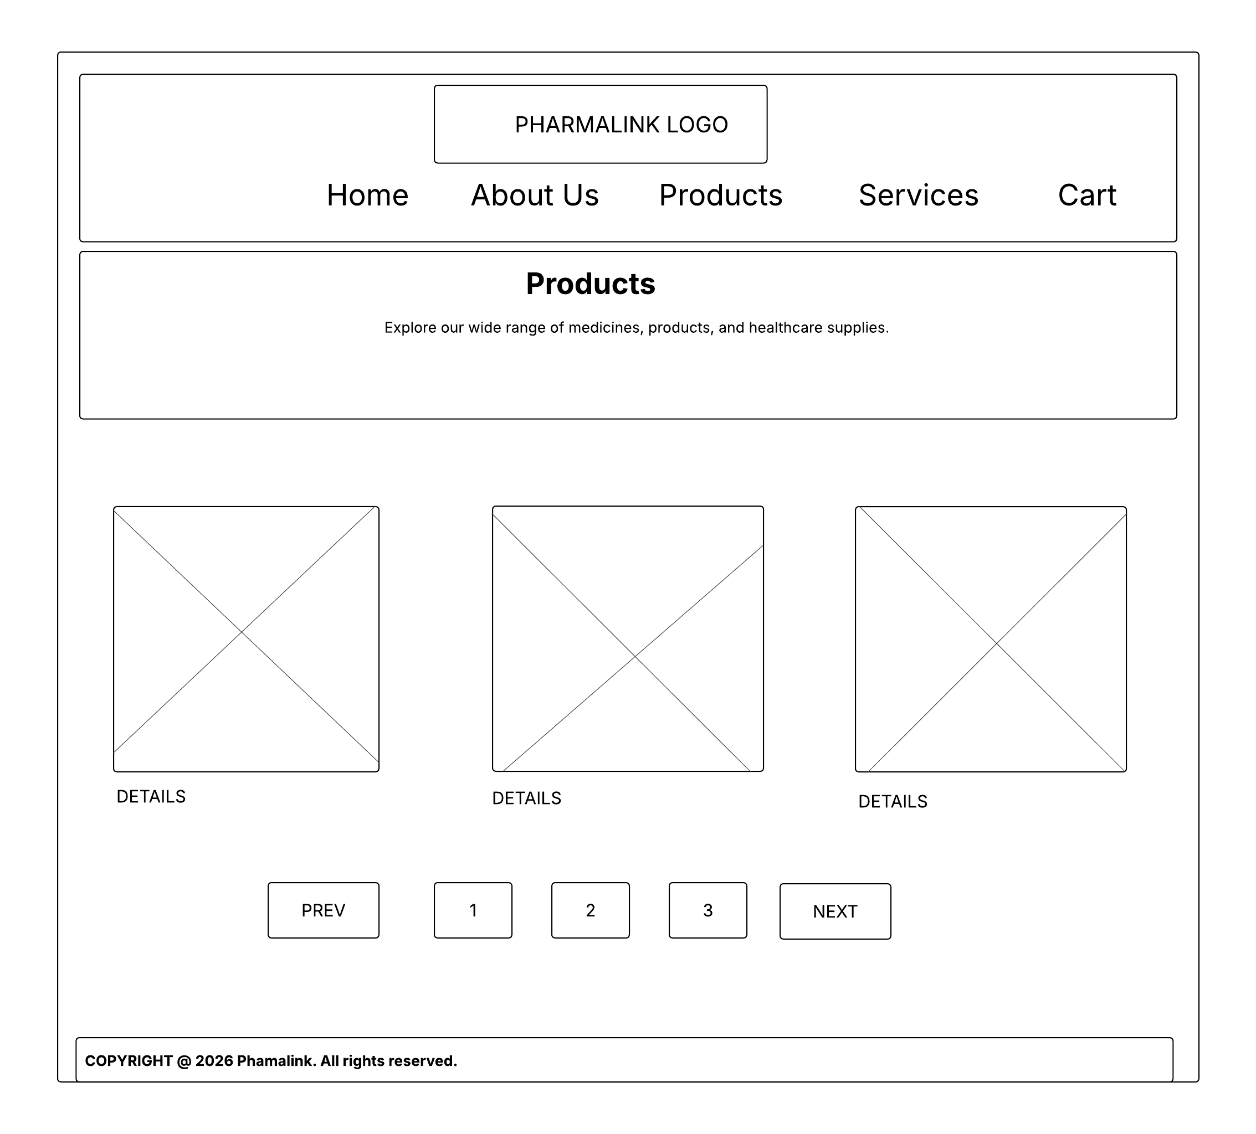
The Products page displays medicine categories and healthcare products in a structured layout for easier browsing.

Cart Page
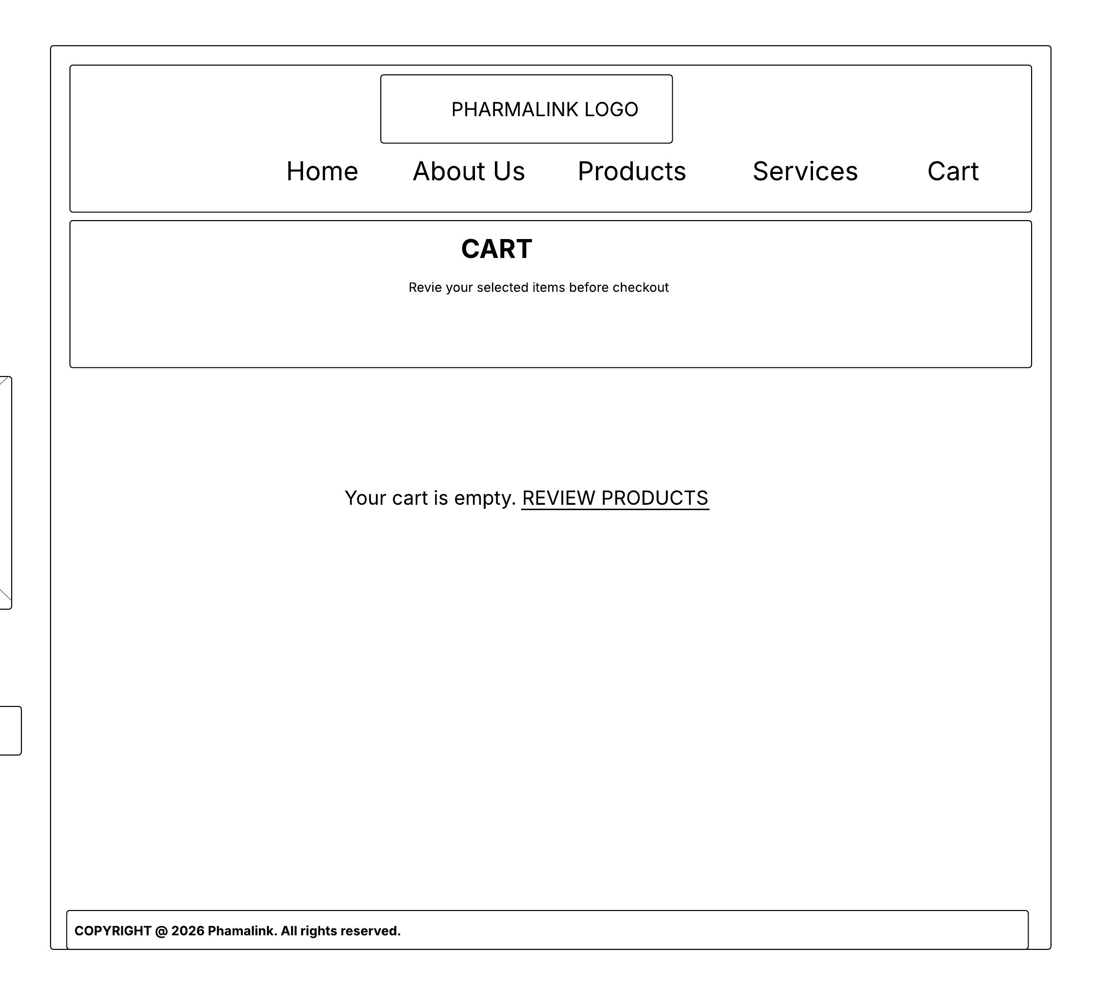
The Cart page allows users to review selected products, update quantities, and manage purchases.

Checkout Page
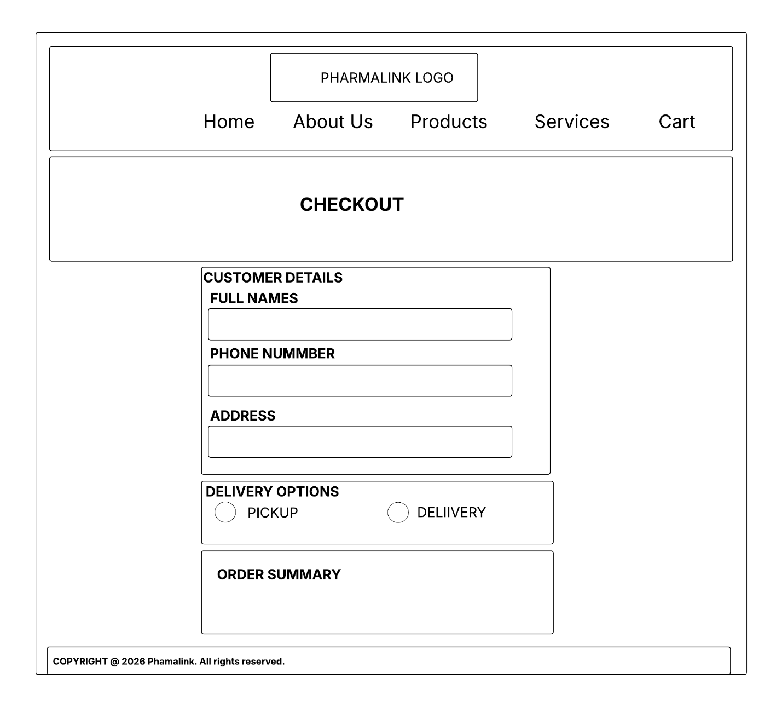
The Checkout page enables customers to enter their information, confirm orders, and complete online purchases.

Services Page
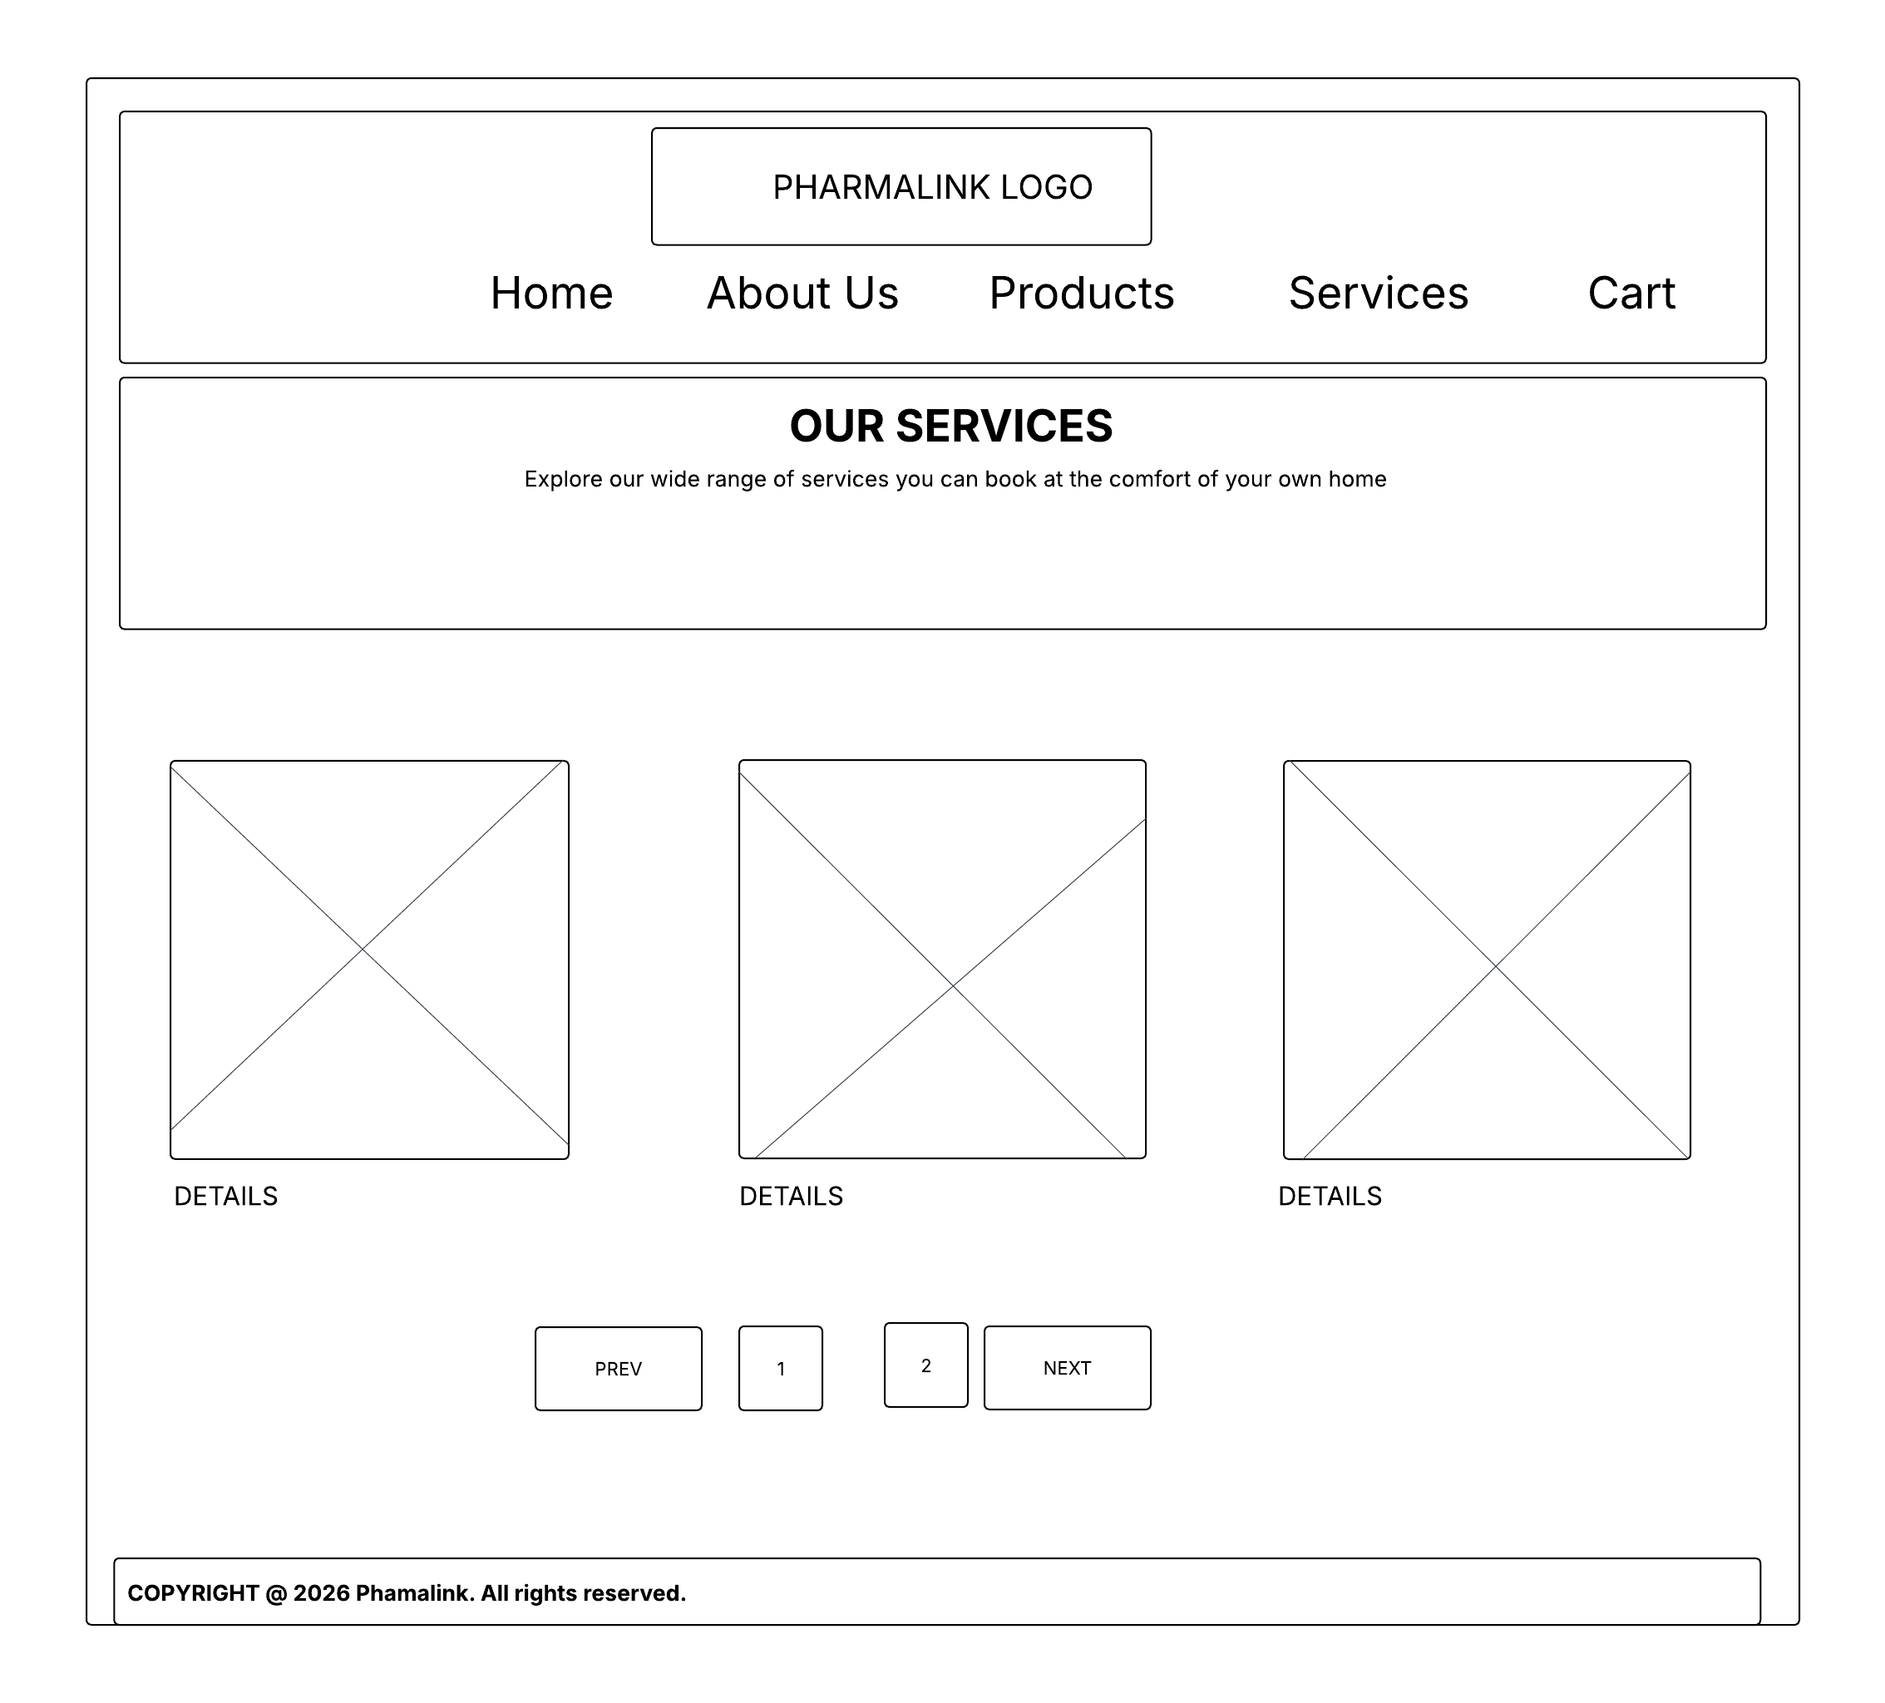
The Services page outlines healthcare services that the pharmacy provides for its customers.

Booking Page
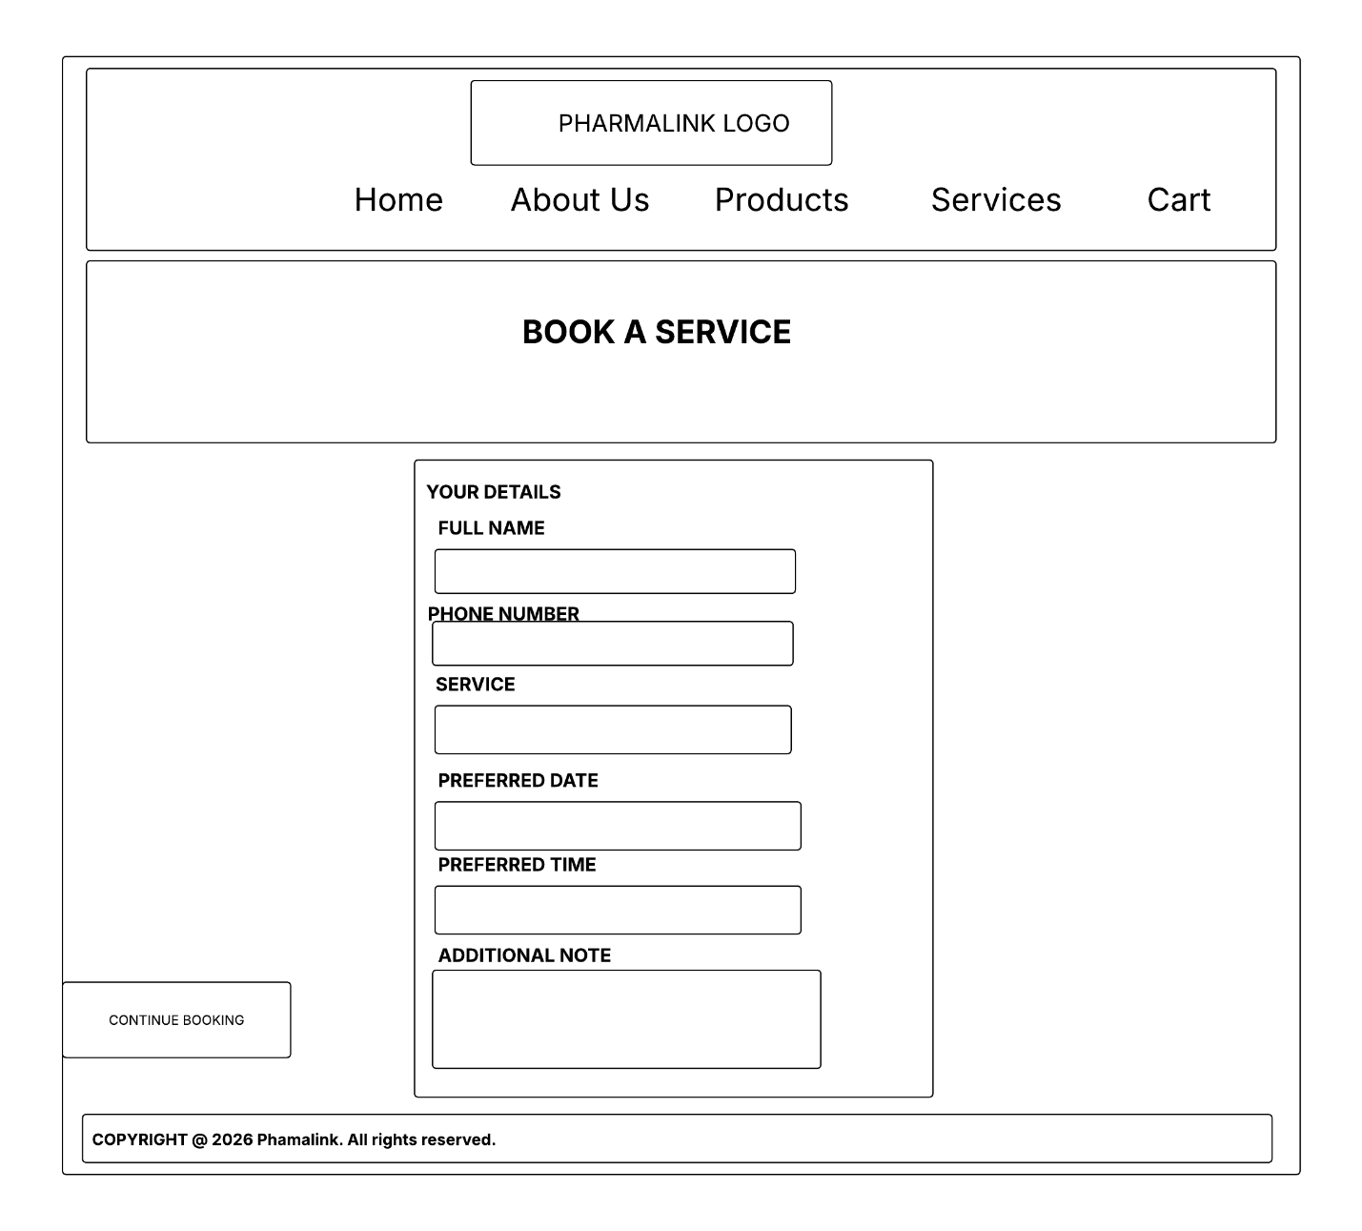
The Booking page allows users to schedule appointments and consultations online.

QUALITY ASSURANCE
Quality assurance is important in ensuring that the PharmaLink website works properly and provides good user experience before it is published for users to use it. Different testing methods have been used during the development process to identify errors and fix them before deployment of the website.

MOBILE DEVICE TESTING
The website was tested to see if it can operate on mobile devices without breaking the layout or functionalities. The test was not successful at first but after debugging and adding a media query the website was able to respond and work well in a mobile device.
The image bellow shows the website before a media query was added.
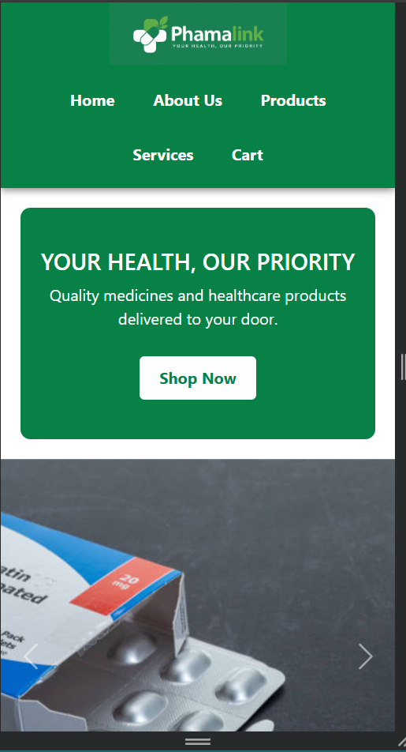

The image below show the website after a media query was added.
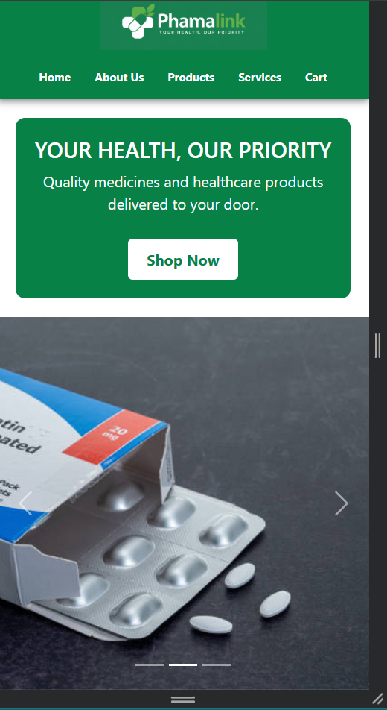

BROWSER COMPATIBILITY TESTING
The website was also tested on multiple browsers to see if it can respond well with some browsers. The test was successful as the website was able to respond well in google chrome, Mozilla Firefox and Microsoft edge.
Below is an image of the website displayed in Mozilla Firefox.:
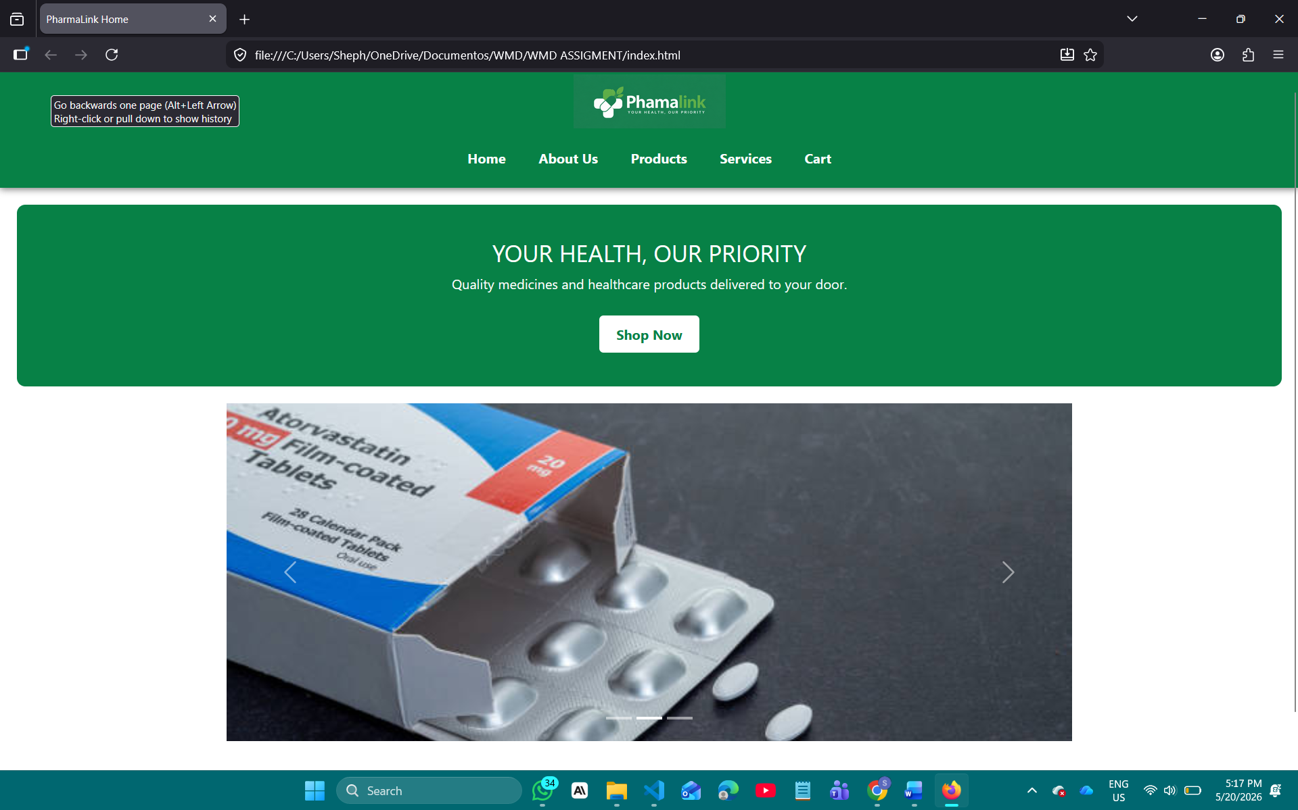

Below is another image of the website displayed in Google Chrome:
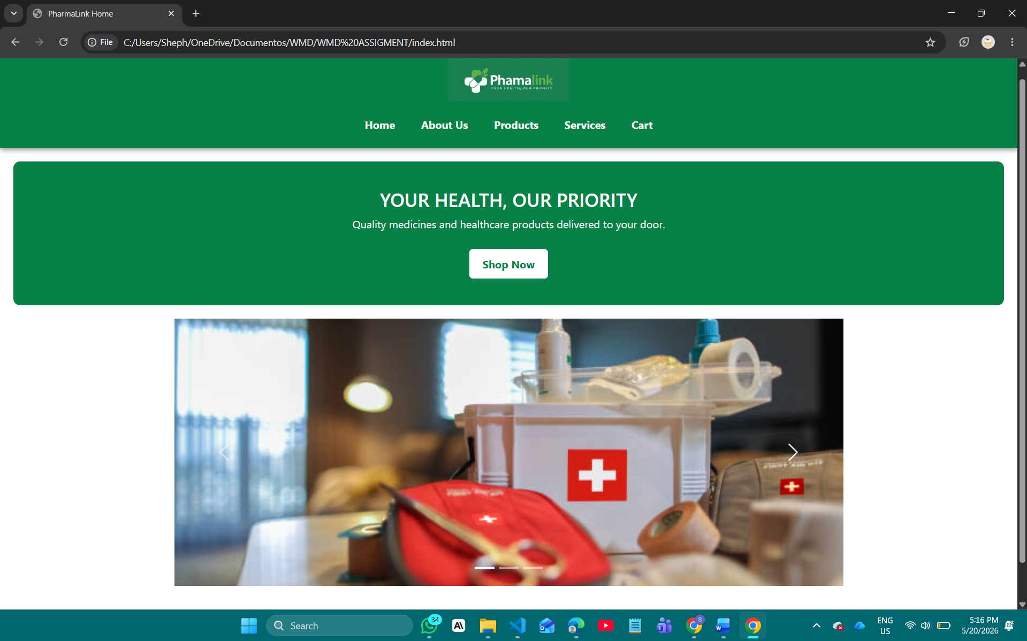
Below is another image of the website displayed in Microsoft edge:
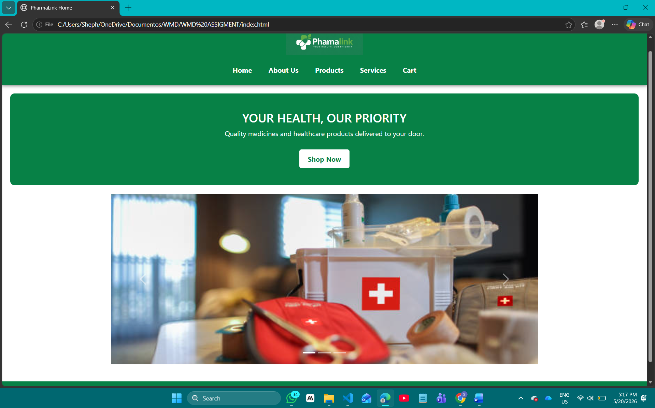
PUBLISHING AND PROMOTION
The PharmaLink website was published using GitHub since it is a free hosting service that allows most developers to publish their websites via GitHub repositories.
GitHub will also be used for version control during the development of the website which helps developers track changes made to files and manage updates properly throughout the project development process. According to GitHub Docs (2024), GitHub provides developers with tools for collaboration, version control, and website hosting through GitHub Pages.
GitHub commands were used in the development and publication of the website. The commands are:
git init
The following command was used to initialize Git in the project folder.

git add .
The following command was used to add files into a staging area.

git commit -m "Updates"
The following command is used to update and save project changes.

git remote add origin https://github.com/cse25-255/WMD-Assignment
The following command was used to connect the local project to GitHub.

git push -u origin main
The following command was used to upload files to GitHub.

FUTURE DEVELOPMENTS/RECOMMENDATIONS
Although the PharmaLink website already provides healthcare and e-commerce services, there are still some improvements that can be added in the future to improve functionality and user experience. The changes are:
Online Payments
The website will soon enable online payments so that users can pay at the comfort of their homes digitally. This will also help in tracking loyal customers and giving them discounts.

User Accounts
The website will also be improved by adding user account features where customers can register, log in, track orders, and manage their personal information.

Delivery Tracking
Delivery tracking functionality can also be added to allow users to monitor the status of their orders in real time.

Advanced Search Features
The website can include advanced search and filtering options to help users quickly find medicines and healthcare products.

Conclusion
PharmaLink is designed to provide a user-friendly healthcare platform that combines pharmacy services with e-commerce service. The website aims to improve convenience, accessibility, communication, and customer satisfaction by allowing users to access healthcare services and products online.
The use of responsive technologies such as HTML, CSS, Bootstrap, and JavaScript ensures that the platform can function effectively across different devices. Overall, the PharmaLink website provides an easier and more convenient way for users to access pharmacy products and healthcare services online at the comfort of their homes.
LINKS
REPOSITORY LINK- https://github.com/cse25-255/WMD-Assignment
URL LINK - https://cse25-255.github.io/WMD-Assignment

References
Garrett, J. J. (2011). The Elements of User Experience: User-Centered Design for the Web and Beyond (2nd ed.). New Riders.
MDN Web Docs. (2024). JavaScript Guide.
Nielsen Norman Group. (2020). Website Usability Principles.
Statista. (2024). Growth of E-commerce in Healthcare.
World Health Organization. (2021). Global Strategy on Digital Health 2020–2025.
GitHub Docs. (2024). Getting Started with GitHub Pages.
Google Developers. (2023). Mobile-Friendly Design Guidelines.
IBM. (2022). Importance of Website Security.

